**Program:** 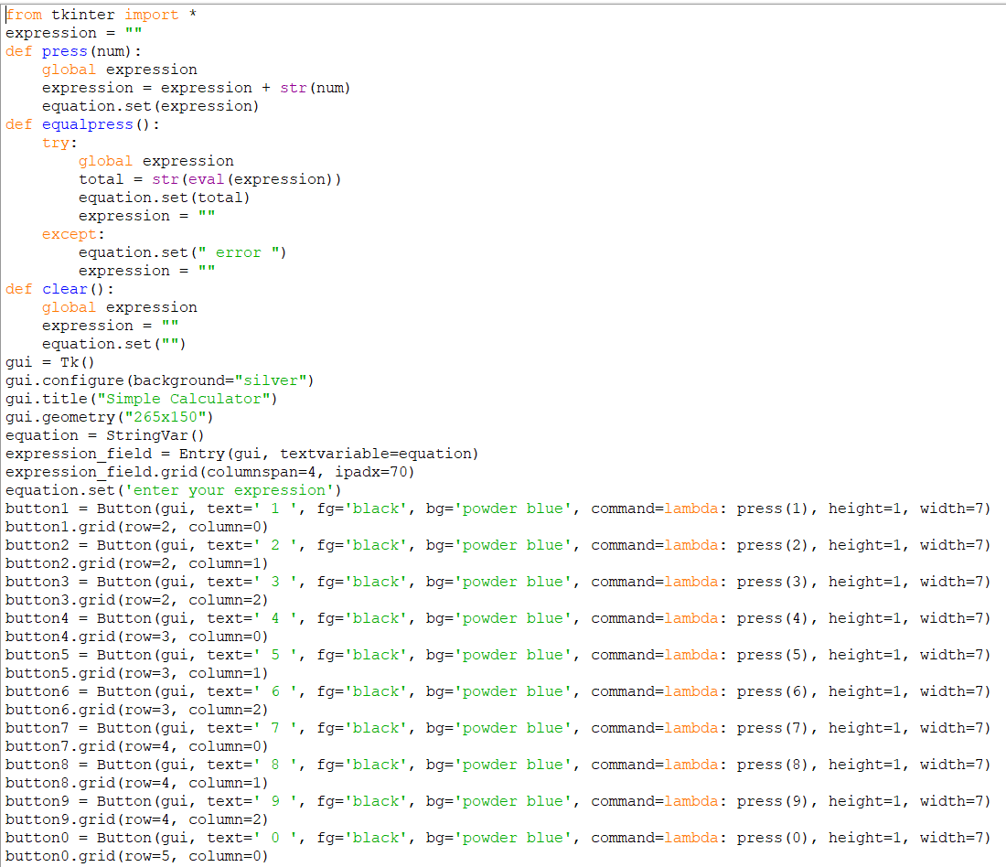

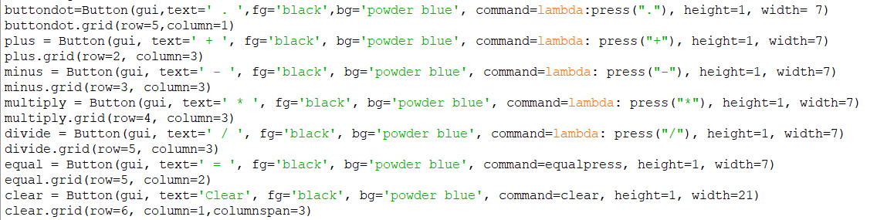

**Output:**

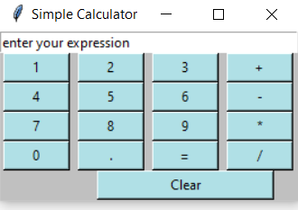

**Program:**

**from tkinter import \***

**expression = ""**

**def press(num):**

**global expression**

**expression = expression + str(num)**

**equation.set(expression)**

**def equalpress():**

**try:**

**global expression**

**total = str(eval(expression))**

**equation.set(total)**

**expression = ""**

**except:**

**equation.set(" error ")**

**expression = ""**

**def clear():**

**global expression**

**expression = ""**

**equation.set("")**

**gui = Tk()**

**gui.configure(background="silver")**

**gui.title("Simple Calculator")**

**gui.geometry("265x150")**

**equation = StringVar()**

**expression_field = Entry(gui, textvariable=equation)**

**expression_field.grid(columnspan=4, ipadx=70)**

**equation.set('enter your expression')**

**button1 = Button(gui, text=' 1 ', fg='black', bg='powder blue', command=lambda: press(1), height=1, width=7)**

**button1.grid(row=2, column=0)**

**button2 = Button(gui, text=' 2 ', fg='black', bg='powder blue', command=lambda: press(2), height=1, width=7)**

**button2.grid(row=2, column=1)**

**button3 = Button(gui, text=' 3 ', fg='black', bg='powder blue', command=lambda: press(3), height=1, width=7)**

**button3.grid(row=2, column=2)**

**button4 = Button(gui, text=' 4 ', fg='black', bg='powder blue', command=lambda: press(4), height=1, width=7)**

**button4.grid(row=3, column=0)**

**button5 = Button(gui, text=' 5 ', fg='black', bg='powder blue', command=lambda: press(5), height=1, width=7)**

**button5.grid(row=3, column=1)**

**button6 = Button(gui, text=' 6 ', fg='black', bg='powder blue', command=lambda: press(6), height=1, width=7)**

**button6.grid(row=3, column=2)**

**button7 = Button(gui, text=' 7 ', fg='black', bg='powder blue', command=lambda: press(7), height=1, width=7)**

**button7.grid(row=4, column=0)**

**button8 = Button(gui, text=' 8 ', fg='black', bg='powder blue', command=lambda: press(8), height=1, width=7)**

**button8.grid(row=4, column=1)**

**button9 = Button(gui, text=' 9 ', fg='black', bg='powder blue', command=lambda: press(9), height=1, width=7)**

**button9.grid(row=4, column=2)**

**button0 = Button(gui, text=' 0 ', fg='black', bg='powder blue', command=lambda: press(0), height=1, width=7)**

**button0.grid(row=5, column=0)**

**buttondot=Button(gui,text=' . ',fg='black',bg='powder blue', command=lambda:press("."), height=1, width= 7)**

**buttondot.grid(row=5,column=1)**

**plus = Button(gui, text=' + ', fg='black', bg='powder blue', command=lambda: press("+"), height=1, width=7)**

**plus.grid(row=2, column=3)**

**minus = Button(gui, text=' - ', fg='black', bg='powder blue', command=lambda: press("-"), height=1, width=7)**

**minus.grid(row=3, column=3)**

**multiply = Button(gui, text=' * ', fg='black', bg='powder blue', command=lambda: press("*"), height=1, width=7)**

**multiply.grid(row=4, column=3)**

**divide = Button(gui, text=' / ', fg='black', bg='powder blue', command=lambda: press("/"), height=1, width=7)**

**divide.grid(row=5, column=3)**

**equal = Button(gui, text=' = ', fg='black', bg='powder blue', command=equalpress, height=1, width=7)**

**equal.grid(row=5, column=2)**

**clear = Button(gui, text='Clear', fg='black', bg='powder blue', command=clear, height=1, width=21)**

**clear.grid(row=6, column=1,columnspan=3)**